HALF/FULL ADDER & HALF/FULL SUBTRACTOR

Aim:
To realize half/full adder and half/full subtractor.
i.Using X-OR and basic gates.
ii.Using only NAND gates.
Apparatus Required:
Digital Trainer Kit, IC 7486, IC 7432, IC 7408, IC 7400, and connecting wires
Procedure:
1.Verify the gates.
2.Make the connections as per the circuit diagram.
3.Switch on V_{CC} and apply various combinations of input according to the truth table.
4.Note down the output readings for half/full adder and half/full subtractor sum/difference and the carry/borrow bit for different combinations of inputs.

Half Adder using basic gates:-
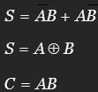
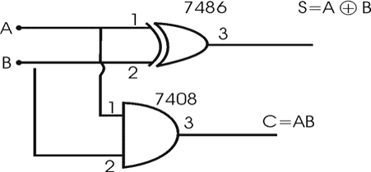
Full Adder using basic gates:-
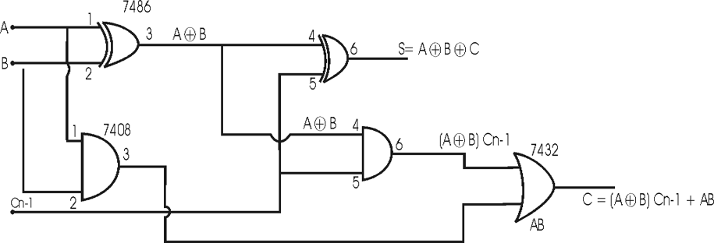

Half Adder using NAND gates only:-
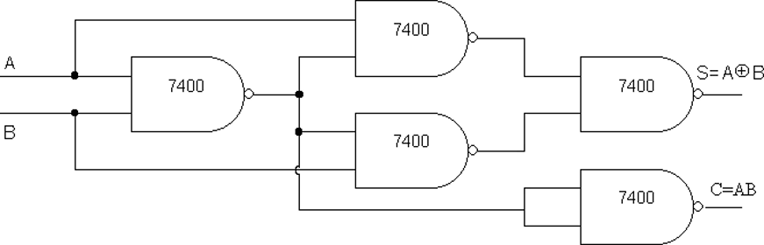

Full Adder using NAND gates only:-

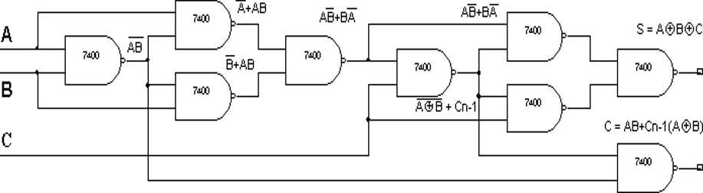

Half subtractor Using only NAND gates:-
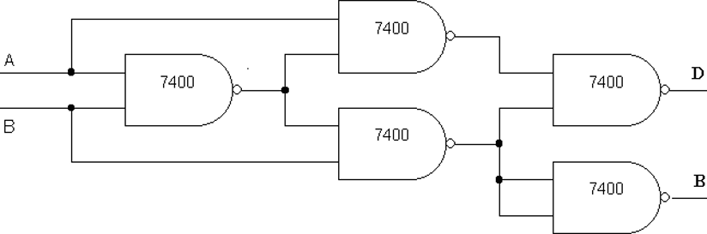

Full Subtractor Using only NAND gates:-
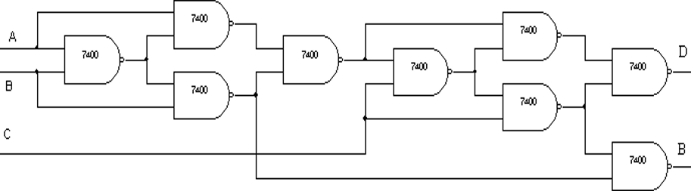

Half Adder
A | B | S | C | S(V) | C(V)
0 | 0 | 0 | 0 | 0 | 0
0 | 1 | 1 | 0 | 1 | 0
1 | 0 | 1 | 0 | 1 | 0
1 | 1 | 0 | 1 | 0 | 1

Full Adder
A | B | Cn-1 | S | C | S(V) | C(V)
0 | 0 | 0 | 0 | 0 | 0 | 0
0 | 0 | 1 | 1 | 0 | 1 | 0
0 | 1 | 0 | 1 | 0 | 1 | 0
0 | 1 | 1 | 0 | 1 | 0 | 1
1 | 0 | 0 | 1 | 0 | 1 | 0
1 | 0 | 1 | 0 | 1 | 0 | 1
1 | 1 | 0 | 0 | 1 | 0 | 1
1 | 1 | 1 | 1 | 1 | 1 | 1

Half Subtractor
A | B | D | B | D(V) | B(V)
0 | 0 | 0 | 0 | 0 | 0
0 | 1 | 1 | 1 | 1 | 1
1 | 0 | 1 | 0 | 1 | 0
1 | 1 | 0 | 0 | 0 | 0

Full Subtractor
A | B | Cn-1 | D | B | D(v) | B(v)
0 | 0 | 0 | 0 | 0 | 0 | 0
0 | 0 | 1 | 1 | 1 | 1 | 1
0 | 1 | 0 | 1 | 1 | 1 | 1
0 | 1 | 1 | 0 | 1 | 0 | 1
1 | 0 | 0 | 1 | 0 | 1 | 0
1 | 0 | 1 | 0 | 0 | 0 | 0
1 | 1 | 0 | 0 | 0 | 0 | 0
1 | 1 | 1 | 1 | 1 | 1 | 1

RESULT:
The truth tables and operation of half/full adder and half/full subractor circuits were successfully verified using logic gates.

